Project Design Phase-II
Data Flow Diagram & User Stories

Date | 8 October 2026
Team ID | SWTID-2026-3520
Project Name | Implement Client Script & UI Policy (Incident)
Maximum Marks | 4 Marks

Data Flow Diagrams:
A Data Flow Diagram (DFD) is a traditional visual representation of the information flows within a system. A neat and clear DFD can depict the right amount of the system requirement graphically. It shows how data enters and leaves the system, what changes the information, and where data is stored.

Data Flow (Simplified)

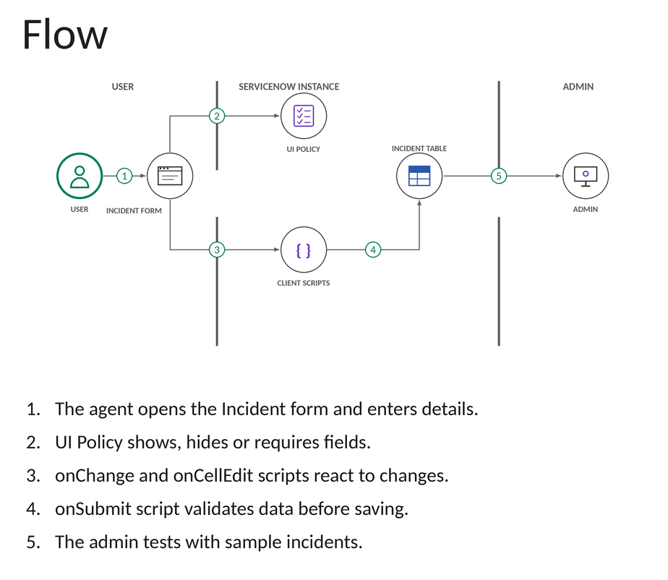

User Stories
Use the below template to list all the user stories for the product.
User Type | Functional Requirement (Epic) | User Story Number | User Story / Task | Acceptance criteria | Priority | Release
Service Desk Agent | UI Policy | USN-1 | As a service desk agent, I can see required fields marked as mandatory on the Incident form, so that I do not save an incident with missing details. | Mandatory fields are highlighted and the form cannot be saved while they are empty | High | Sprint-1
 |  | USN-2 | As a service desk agent, I can see only the fields that apply to the incident, so that the form stays simple. | Fields show or hide automatically based on the selected values | Medium | Sprint-1
 | UI Policy Action – Urgency | USN-3 | As a service desk agent, when I set Urgency to High, I am asked for the related details, so that urgent incidents carry the information needed. | Related fields become mandatory / visible when Urgency is High and return to normal when it changes | High | Sprint-1
 | onChange Client Script | USN-4 | As a service desk agent, I get an instant message when I change a key field, so that I can correct a value before saving. | A message or auto-fill appears right after the change, without submitting the form | High | Sprint-2
 | onSubmit Client Script (Save Validation) | USN-5 | As a service desk agent, I am stopped from saving invalid data, so that wrong values never reach the Incident table. | Save is blocked when validation fails and the record is saved only when all checks pass | High | Sprint-2
 |  | USN-6 | As a service desk agent, I see a clear error message that names the field to fix, so that I can resubmit quickly. | The message points to the exact field and disappears once the value is corrected | Medium | Sprint-2
Incident Fulfiller (List view user) | onCellEdit Client Script | USN-7 | As an incident fulfiller, I can edit values directly in the list view and have them validated, so that list edits follow the same rules as the form. | Valid cell edits are saved; invalid values are rejected with an alert message | High | Sprint-2
 |  | USN-8 | As an incident fulfiller, I get an alert when a cell value is not allowed, so that I know why the edit was not accepted. | The alert shows the reason and the original value stays in the cell | Medium | Sprint-2
ServiceNow Administrator | UI Policy & Client Script setup | USN-9 | As an administrator, I can configure the UI Policy, UI Policy Action and Client Scripts on the Incident table, so that field behavior is controlled in one place. | All configured rules are active and visible on the Incident table | High | Sprint-1
 | Testing the Configuration | USN-10 | As an administrator, I can test the configuration with sample incidents, so that I know every rule works before it is used. | Valid and invalid inputs give the expected result on the form and the list view | High | Sprint-3
Queue Owner | Data Quality | USN-11 | As a queue owner, I receive incidents with complete and correct data, so that assignment and reports stay accurate. | Saved incidents have the required fields filled and consistent Urgency values | Medium | Sprint-3
Project Team Member | Documentation | USN-12 | As a team member, I can see the documented rules and test results, so that the configuration can be reviewed and maintained. | Rules, screenshots and test results are available for review | Low | Sprint-3

